You need to set java version: 17

To check the version of java

**java -version**

then download the jenkins.war

**java -jar jenkins.war**

by default Jenkin run on port number 8080.

<http://localhost:8080>

initially it will ask you password. You can find the password on terminal

once you provided password. You need installed suggested plugin.

Then create your account.

**Trigger :**

This option is use to tigger or execute automatically based upon type of trigger we selected.

Build periodically

In this option we need to provide time.

**Now we create Jenkin Job with Trigger option. Trigger need to execute whenever any change happens in project.**

Build periodically

With time option as

* * * * * *

Creating another Jenkin job whenever developer push the code that time only build the project.

**Poll SCM**

With time as -> * * * * *

Every minute Jenkin hit to git hub account to check any new changes happen on that particular branch. if yes then build else doesn’t build.

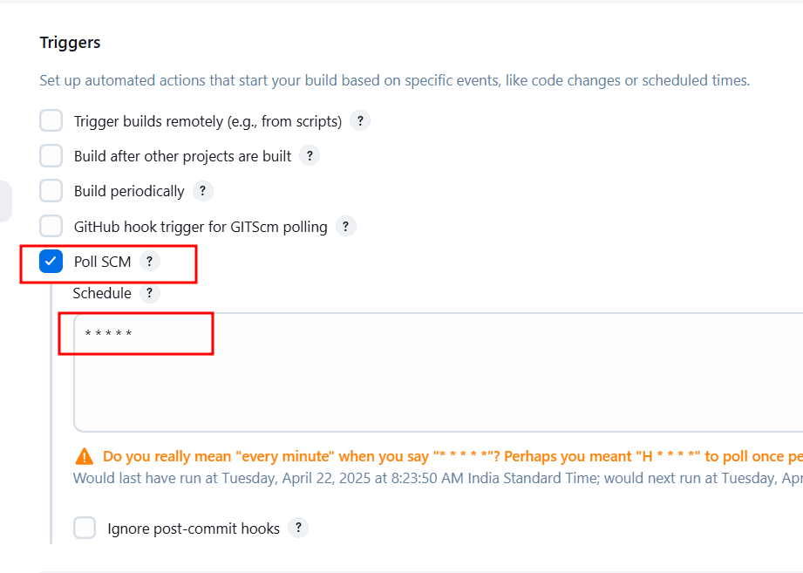

Creating Jenkin job to build spring boot projects.

Spring boot project use maven build tools.

Maven provided set of command to build the project.

mvn clean (clean the projects)

mvn compile (compile all files present in your projects)

mvn test (do junit testing)

mvn package (create jar or war file)

mvn install

these command we need to execute in location (where pom.xml file present).

First download the maven tool